Natural Bread Price List 20th March '26

Sourdough Bread [v] =Vegan  Frozen at -18°c our breads will keep for 6 months if needed. | Size | Shop price
NEW German Rye Sourdough [v] DARK RYE so%, LIGHT RYE 25%, WHITE WHEAT 25%  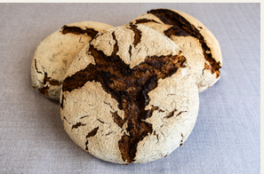 | 900g | £6.90
Three Seeded Sourdough [v]  WHITE WHEAT 60%, WHOLEMEAL FLOUR 30%, LIGHT RYE 10%, PUMPKIN, SUNFLOWER & LINSEEDS  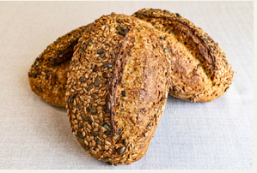 | 500g | £5.10
Oxford Sourdough [v] 90% WHITE WHEAT, 10% RYE-  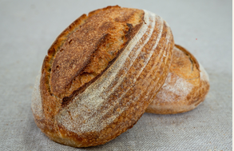 | 800g  500g | £5.50  £4.50
Brainy Long Sourdough (v] Brainy Tin Sourdough [v]  80% STONEGROUND WHOLEMEAL WHEAT, 15% WHITE WHEAT, 5% RYE  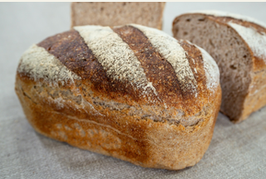 | 1800g  830g | £9.80  £5.90
Miehe Long Sourdough [v] Miehe Tin Sourdough [v]  30% SPELT, 65% WHITE WHEAT, 5% RYE  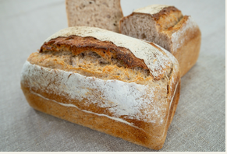 | 1800g  820g | £9.80  £6.10
Pain au Levain Long Sourdough [v] | 1800g | £9.80
Pain au Levain Round, Sourdough [v)  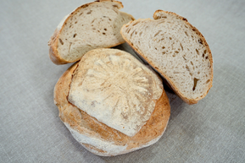 | 780g | £5.50
Pain au Levain Tin Sourdough [v] | 800g | £5.50
95% WHITE WHEAT, 5% RYE  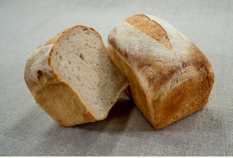 | 540g | £4.90
Baguette au Levain Sourdough [v] 95% WHITE WHEAT, 5% RYE  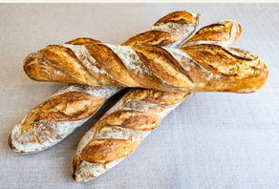 | 390g | £3.90
Multigrain Sourdough [v]  80% SEEDED GRANARY, 15% WHITEWHEAT, 5% RYE  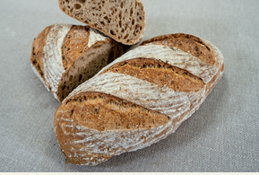 | 800g | £6.50
Spelt Sourdough [v] 50% WHITE SPELT, 45% BROWN SPELT, 5% RYE  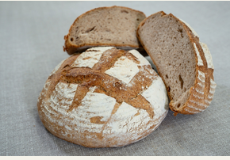 | 840g | £6.90
Chia Seed Sourdough [v] 30% SPELT, 65% WHITE WHEAT, 5% RYE, CHIA SEEDS  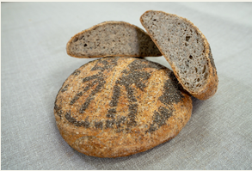 | 780g | £6.90
Rye with sunflower seeds Sourdough [v] 100% RYE, SUNFLOWER SEEDS  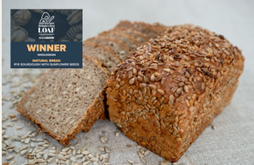 | 850g | £7.10
Rye Sourdough [v] 100% RYE  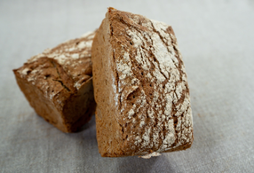 | 420g | £4.80
Walnut Sourdough [v] 30% SPELT, 65% WHITE WHEAT, 5% RYE, WALNUTS  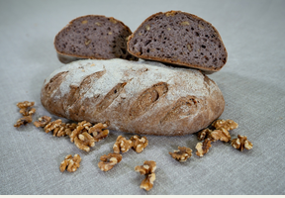 | 800g | £6.90
Sweet Potato Sourdough [v] 50% WHITE WHEAT, 5% RYE, 45% SWEET POTATO  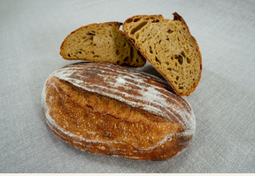 | 800g | £6.60
Sweet Potato Sourdough with Cheddar Cheese & Coriander  50% WHITE WHEAT, 5% RYE, 45% SWEET POTATO  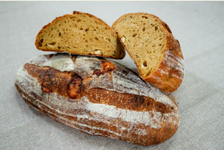 | 780g | £6.90
Olive Sourdough [v] 30% SPELT, 65% WHITE WHEAT, 5% RYE, MIXED OLIVES & HERBS  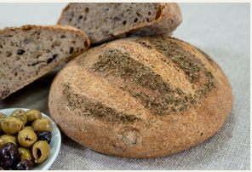 | 420g | £4.90
Pugliese Sourdough [v] 100% ORGANIC DURUM WHEAT FROM PUGLIA, ITALY  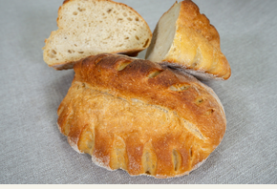 | 850g | £7.00

Yeasted Bread [v] =Vegan  Frozen at -18°c our breads will keep for 6 months if needed. | Size | Shop price
White Farmhouse [v]  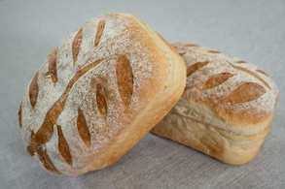 | 800g  420g | £3.80  £2.90
La Soupiere [v] | 420g | N/ A
White Sandwich Loaf [v]  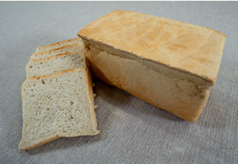 | 800g | £3.80
Granary Sandwich loaf [v]  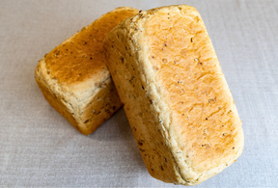 | 800g | £4.10
Wholemeal Sandwich loaf [v]  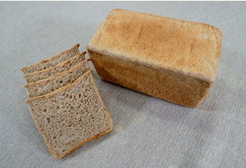 | 800g | £4.20
Sandwich Baguette [v] | 160g | £1.50
White Bloomer [v]  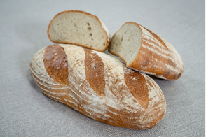 | 800g | £3.60
Granary [v]  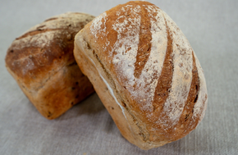 | 800g  420g | £3.90  £3.00
Wholemeal Farmhouse [v]  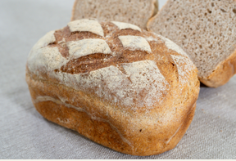 | 800g | £4.20
Seeded Wholemeal [v]  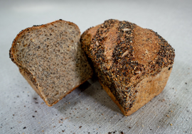 | 680g | £4.60
Spelt [v]  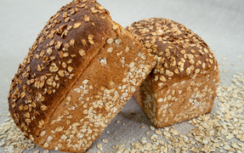 | 690g | £5.60
Focaccia [v - excluding for Chilli, Cheese & Chive]  Plain/ Rosemary/ Sun dried tomato/ Olive/ Fresh tomato, garlic & rosemary/ Chilli, Cheese & Chive  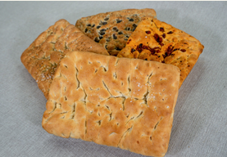 | 900g | £5.50
Challah  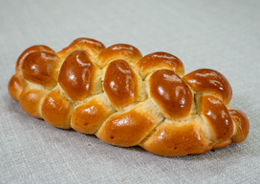 | 480g | £5.00
Fruit Loaf  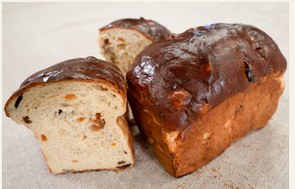 | 590g | £4.30
Brioche Loaf  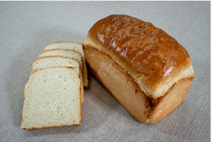 | 800g  280g | £4.90  £3.20

Rolls & Burger Buns | Size | Shop price
Foccacio Roll  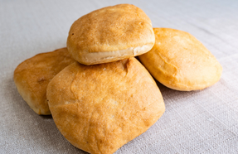 | 100g | £0.70
Brioche Burger Bun  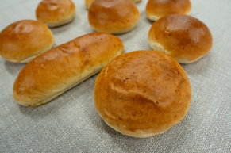 | 90g  70g  50g | £0.70  £0.60  £0.55
White Sourdough Roll  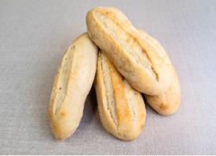 | 170g  75g | £1.20  £0.60
Multigrain Soughdough Roll  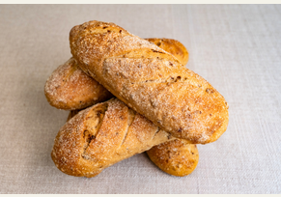 | 170g | £1.30
Hot Dog Roll  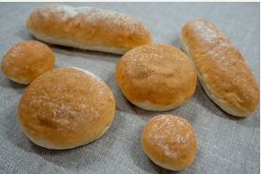 | 120g | £0.70
White Roll [vl | 100g  70g  20g | £0.60  £0.35  £0.20

Wholemeal Rolls [v}  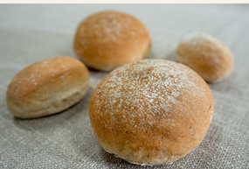 | 100g | £0.60
 | 70g | £0.35
 | 20g | £0.20
Dinner Rolls [v] - available on request  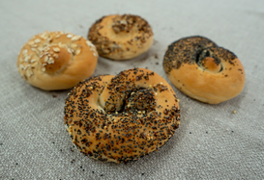 | 30g | £0.35
Hedgehog [v]  Hedgehogs  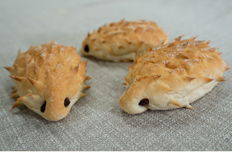 | 65g | £1.00
Bagels  Plain/Poppy Seed /Five Seeds Mix  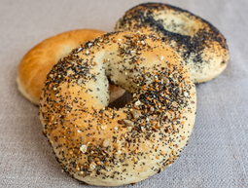 | 100g | £1.60

Pastries |  | Shop price
!!NEW. Apple & Cinnamon Danish  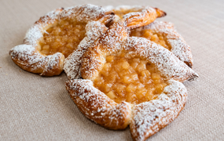 | £2.40 | £3.20
Chelsea Bun  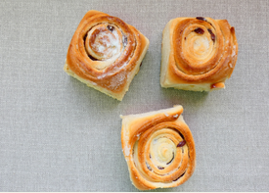 | £2.50 | £3.30
Croissant  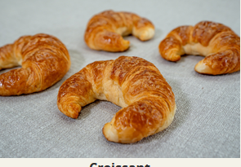 | £2.20 | £2.70
Pain au Chocolat  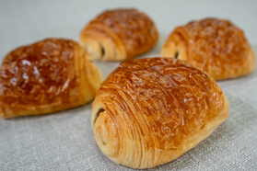 | £2.40 | £3.20
Pain aux Raisins  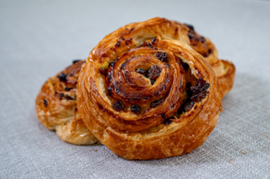 | £2.40 | £3.20
Cinnamon Bun  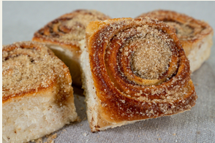 | £2.50 | £3.30
Apricot Danish  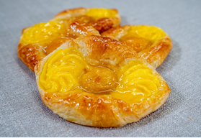 | £2.40 | £3.20
Cherry Danish  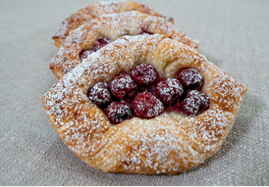 | £2.40 | £3.20
Pain au Beurre Sale  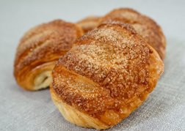 | £2.40 | £3.20
Almond Croissant  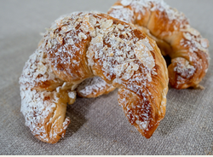 | £3.00 | £3.50
Almond Pain au Chocolat  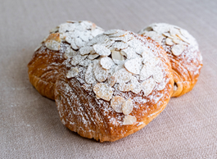 | £3.00 | £3.50
All Gingerbreads  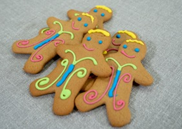 | £2.10 | £2.60
Plain/ Fruit/ Cheese Scones | £1.40 | £1.80
Pistachio Croissant  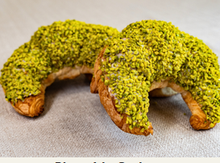 | £3.20 | £3.70

Bread Slicing, Packaging

- Our breads and pastries packaged in sealed, labelled, recyclable plastic bread bags.
There is a 15p surcharge per product for this service.
- Our loaves either medium sliced (11mm) or thick sliced (14mm) and packaged in sealed, labelled, recyclable plastic bread bags.
There is a 20p surcharge per loaf for this service.
- Our rolls can be sliced and packaged in sealed, labelled, recyclable plastic bread bags.
There is a 5p surcharge per roll for this service.

https://www.naturalbreadcompany.co.uk/

